

**Introduction to Computer Vision**

**Coursework**

**Submission**

**Kiana Hadysadegh**

**230632224**

**Transformations**

**Question 1(b):**



**Rotated images:**

θ = -50 deg

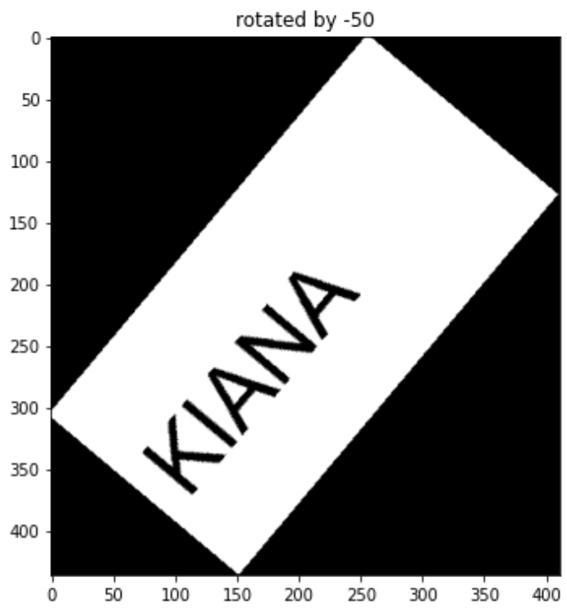

θ = 60 deg

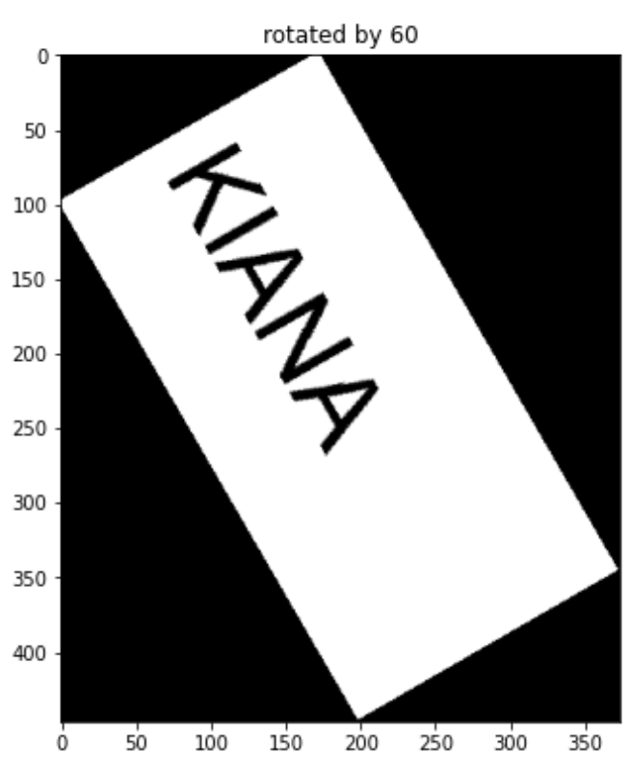

θ = 30

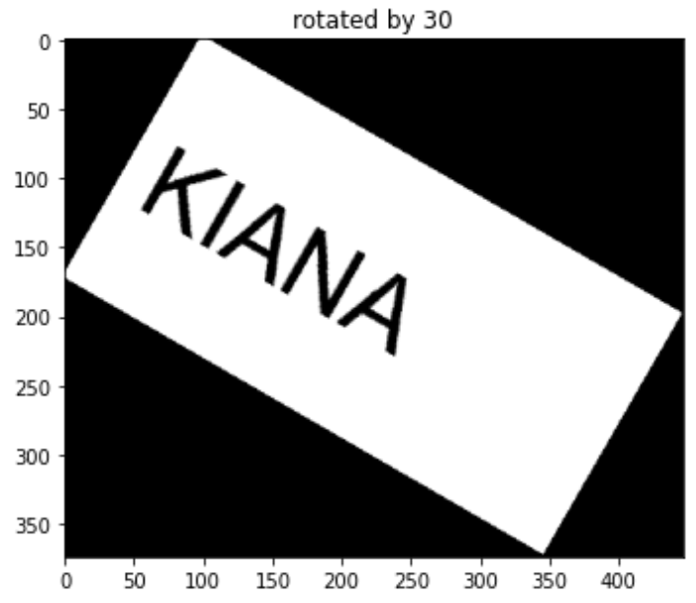

θ = 120 deg

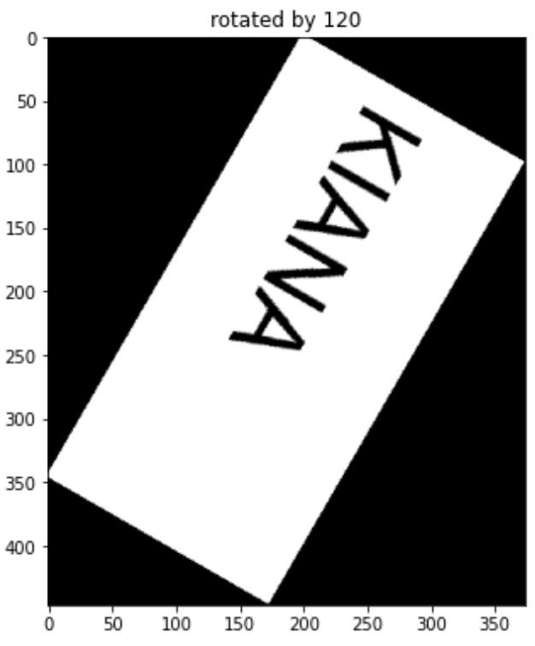

**Skewed images:**

θ = 10 deg

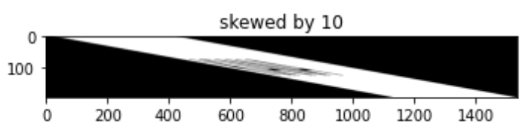

θ = 40 deg

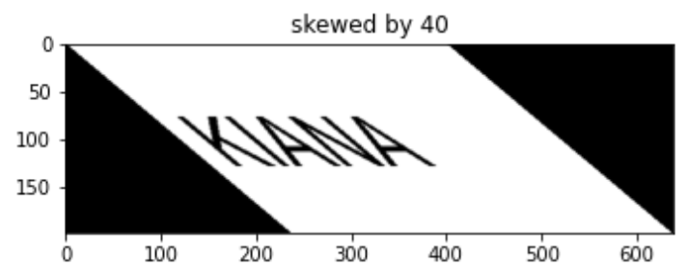

θ = 60 deg

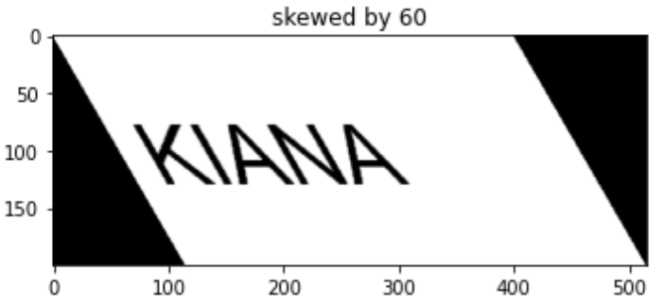

**Your comments:**

-FIRST YOU USED FORWARD MAPPING

-THEN U FIXED MISSING PIXELS WITH INVERSE MAPPING

- WHY DIDN’T YOU USE INTERPOLATION

REQUIRES PADDING?NOT AS ACCURATE? TAKES LONGER?

-DID NOT USE GRAY SCALE BECAUSE ? DIDN’T KNOW? ETC

-DID U USE MUL OR MANUAL POINT FINDING

-WRITE WHAT THE MATRICIES ARE

-TALK ABOUT POINT OF ORIGIN

-HOW DID U DERIVE NEW IMAGE SIZE

-DID YOU HAVE ANY PROBLEMS WITH SHEARING

REMEMBER TO COMMENT AND ANSWER THE SPECIFIC QUESTIONS HE TALKED ABOUT (WHY IS I THEN II AND II THEN I NOT THE SAME?

TALK ABOUT MISTAKES IF YOU MADE ANY

HOW YOU SOLVED THEM ETC

**Question 1(c):**

θ2=50 and θ1=20 clockwise

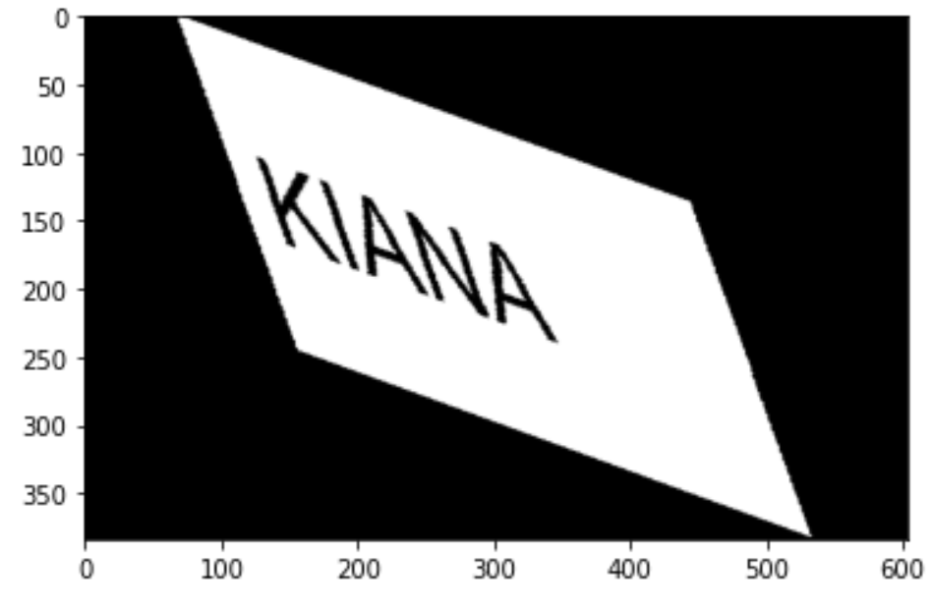

θ1=20 clockwise and θ2=50

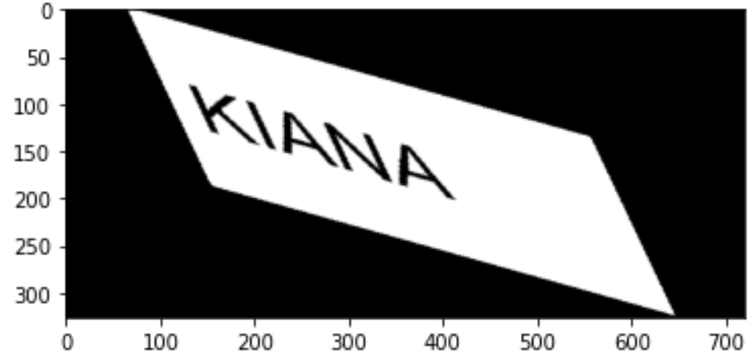

**Your comments:**

**Convolution**

**Question 2(b)**:

**Designed kernel:**

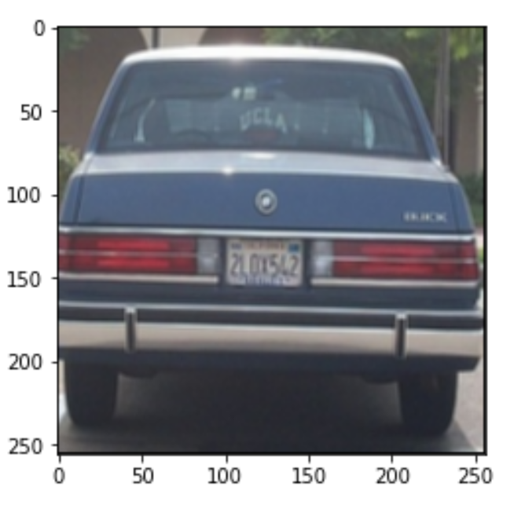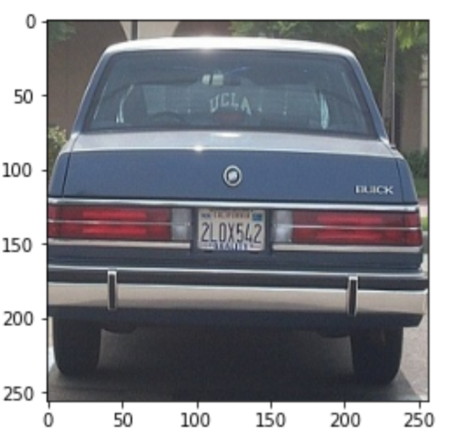

**Your comments:**

**Question 2(c):**

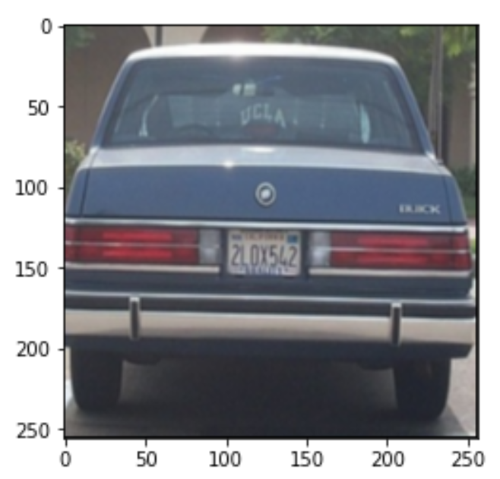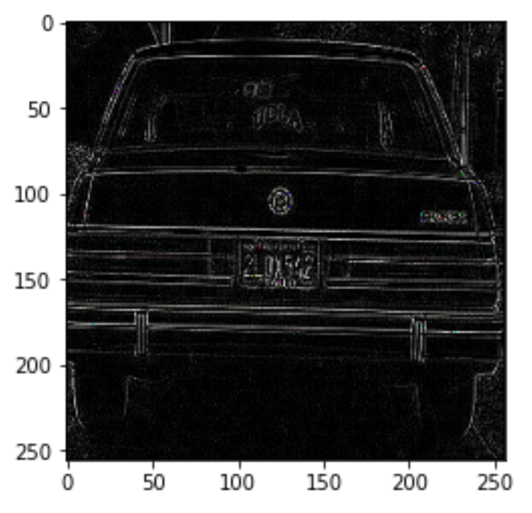

**Your comments:**

**Question 2(d):**

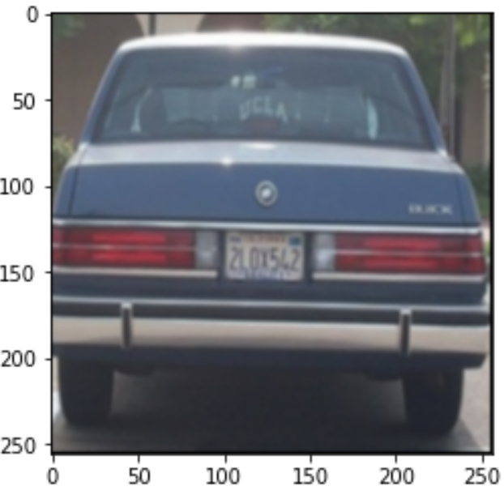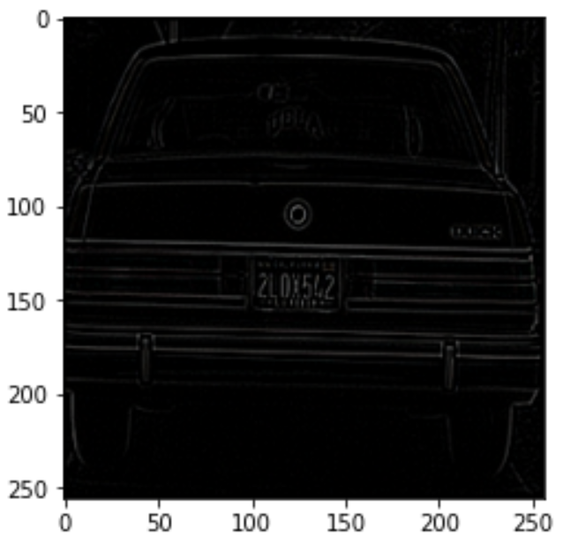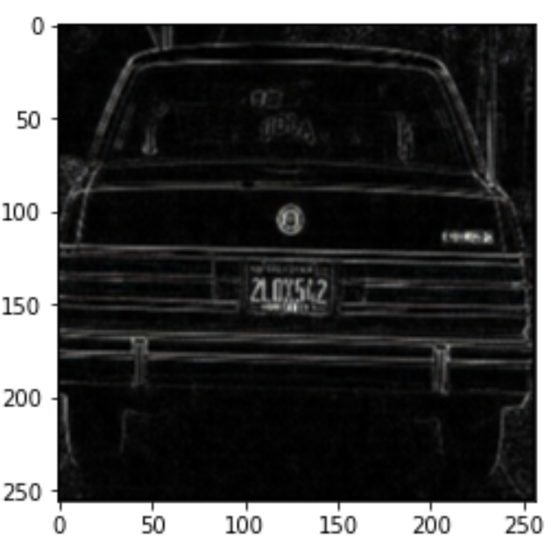

**Your comments:**

-MATMUL OR FOR LOOPS FOR FINDING SLOT

-HOW DID YOU IMPLEMENT IT FOR LARGER MATRICES

-UNDERSTOOD NORMALISATION

-HOW DID U DERIVE AVERAGE INTENSITY KERNEL

-DID YOU NORMALISE IT TO MAKE UP FOR ENERGY

-NAMES OF DIFFERENT KERNELS

-HOW DOES GAUSSIAN SMOOTHEN AN IMAGE

-IS IT BETTER THAN AVERAGE INTENSITY

-HOW DOES LAPLACIAN DETECT EDGES

-HOW COULD IT BE IMPROVED

-USE MATRIX IN EXPLANATION

2D TALK ABOUT ORDER OF OPERATIONS

WHY DOES ONE AFTER ANOTHER HAVE A DIFFERENT OUTPUT

**Histograms**

**Question 3(a):**

**Two non-consecutive frames:**

Image 2

Image 1

**Corresponding colour histograms:**

Histogram 2

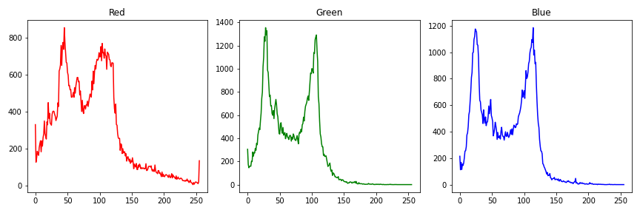

Histogram 1

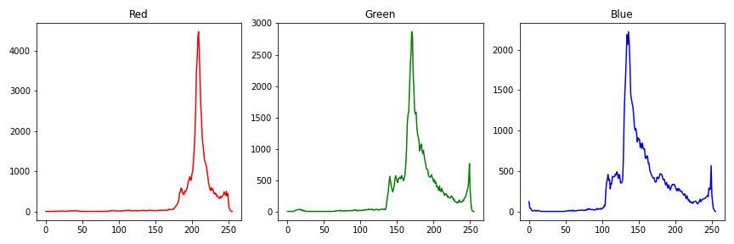

**Your comments:**

**Question 3(b):**

**Two consecutive frames:**

It

It+1

**Histograms:**

Histogram of It

Histogram of It+1

Intersection result

**Question 3(b):**

**Intersection result for a video sequence:**

Intersection result

Normalized intersection result

**Your Comments:**

**Question 3(c):**

**Comments:**

**Texture Descriptors and Classification**

**Question 4(a)**

**Three non-consecutive windows**

W1

W3

W2

**LBP of windows**

LBP1

LBP3

LBP2

**Histograms of LBPs**

H1

H3

H2

**Question 4(b)**

**Two example images:**

Face image

Car image

Face descriptor

Car descriptor

**Descriptors:**

**Your comments:**

**Question 4(b)**

**Block diagram of classification process**

**Your comments:**

**Question 4(c)**

**Your comments:**

**Question 4(d)**

**Your comments:**

**Question 4(e)**

**Your comments:**

**Object Segmentation and Counting**

**Question 5(a)**

**Original frames:**

Reference frame

Selected frame 1

Selected frame 2

**Frame differencing:**

**Threshold results:**

**Question 5(b)**

**Original frame:**

Selected frame 1

Selected frame 2

**Frame differencing:**

**Threshold results:**

**Your comments for 5a,5b:**

**Question 5(c)**

Generated background

**Your comments:**

**Question 5(d)**

Bar plot

**Your comments:**